The script of a play
“THE HOPE FOR EUROPE”
From each country there is one representative in a national costume or wearing a national symbol, decoration, etc. They all are on the stage.
These scenes were filmed in partners’ country. The videos were brought to Mažeikiai. Italian partner mounted them all together after rehearsal of the beginning and the ending of the common play. These parts of our play we filmed in Mažeikiai at Kalnėnų basic school.
- The 1st character tells his story: a performance of Italy.
- The 2nd character tells his story: a performance of Romania.
- The 3rd character tells his story: a performance of Turkey.
- The 4th character tells his story: a performance of Latvia.
- The 5th character tells his story: a performance of Lithuania.
The beginning:
Europe (she has a lot of flags in her hands) comes on the stage picking the flags one by one, chooses our partners’ flags and, showing them, says,
“I can see a new brotherhood. I know, that you will make this world better, than it is now.I believe that you’ll bring people peace and happiness. What are your stories?”
Dear Italy, what is your story? An Italian video.
Such positive kids will make their dream come true.
Dear Turkey, let’s listen to your story. A Turkish video.
The story of Turkey was really impressive.
Dear Romania, what is your story? A Romanian video.
The Romanian story teaches us to save our planet. If we all learn this lesson, the future will be beautiful.
Dear Latvia, what is your story? A Latvian video.
I’m proud of those people you have got in your country. Such people will enrich our culture, science with their creativity and talents.
Dear Lithuania, what is your story? A Lithuanian video.
We all are a happy family now. My dear friends, only together we are a great power.
The ending:
Europe invites everyone. All countries say:
“1.We are different.
2.We sing different songs.
3.We listen to different music.
4.We speak different languages.
5.We wear different clothes.”
All together: “But we respect the same values.
1.Peace and Love.
2.Family and Friendship.
3.Health and Nature.
4.Beauty and Life.
All together: We are the hope for Europe!”
All participants join them and sing a project song “We wish we could fly”
SCRIPTS: Descriptions of performances:
The Turkish play.
Nasreddin Hodja: Hi, I come from Turkey and greet you all with love.
Can: Who are you?
Hodja: I am Nasreddin Hodja.
Ubeyde: Why do you wear these clothes?
Hodja: Because I am a hodja. I teach religious rules and tell jokes. Religious leaders have specific clothes.
Ceren: Your hat is funny.
İrem: Is it heavy?
Yusuf Kayra: Is it hard to carry it?
Elif Pelin: Is it hard to carry it? Why do you wear it?
Hodja: Yes, it is a little heavy. This is my shroud. It will be my dress when I die.
I'd like to give you some information about where I came from. Turkey is a peninsula who has hosted many civilizations. The foundations of civilizations were laid on these lands.
There is Göbekli Hill (the world’s first temple) that takes world history back to the earliest times and is under? UNESCO protection.
The Sumerians are the oldest people who use writing and the tablets of this nation are in Turkey.
Turkish words are also included in Sumerian. As we understand it from here, Turkish speakers and Sumerian speakers have been in contact.
A similar inscription of Orhun, which is one of the oldest written sources of the Turks in Mongolia, is in Bitlis. These stones are grave stones and inscriptions. These stones are the bearer of our culture.
Ancient Greek civilization, and therefore the foundations of Western civilization were laid on these lands. Member countries of European Union’s roots are based on this unity and roots. The literary works which are the most beautiful examples of this are a cultural heritage.
Even, many of the mythological elements are on Turkish land. For example, Olympos and its legend are in Antalya. In this mythological story, an event that symbolizes a dragon is described.
Syriacs, Armenians, Greeks and Hebrews live in this land with us. The languages and religions of these nations are different, but they live here in peace.
Nevsehir is a city where Christianity was protected and spread. There are many underground cities in this city. In these cities, during the time of war, people hid and saved their lives.
Me, Nasreddin Hodja is a well-known character for my jokes in Turkey. I ride donkey especially in reverse.
Ferudun: Why do you ride a donkey in reverse?
Hodja: Because I don't turn my back to kids and so that I want to answer whatever the kids ask. They're our future. I want to show you a photograph of my grave. As you can see, I'm a humorous person.

The Romanian play
Narrator: Somewhere in Romania a little girl is working in her lab. She is a talented scientist working hard to bend time.
Girl: I’m tired of this city full of buildings and people, people that do not share my vision. When my time-machine will be ready, I will go to the future. Everything will be better there, I am sure of it. (She keeps working in her laboratory for days.
After a while she sets the timer for 2220 and hits the start button. And it works. She travels through time into the future.)
Girl: Woooow……but what just happened?
Narrator: There are no trees or flowers. It’s crowded with junk instead. The roads are blocked with garbage. The skies are grey with smog. She starts to cry.
Girl: I worked so hard to travel into the future, so that I may meet other scientists. And I am here all alone. And my machine is broken now: I wonder where the timer is.
She is kicking the plastic bottles with her feet. Suddenly she hears someone calling:
Arduino: Hey little girl. I am here too.
Girl: Who is there?
Arduino: It is I Arduino.
Girl: But what are you?
Arduino: I was designed by humans. I am the only one left on the planet.
Girl: Where is the world I know? Where are the trees? Where is the Sun? Where are the flowers and the bees? Where are the rivers and the fish?
Arduino: The planet is dead. No plants, no animals, no humans could survive. Because all this plastic has poisoned the waters, and the smoke poisoned the air. The Sky was so black that the sun could not reach the surface. So they all died.
Girl: But I can breathe. Check your scanners.
Arduino: I did. The air became Poison less than 50 years ago.
Girl: How can we make the planet what it used to be?
Arduino: I don’t know. There is nothing left.
Narrator: The girl starts looking for something into the garbage. She hopes to find her timer and fix the machine. She looks and looks but the pile of garbage is huge and that timer could have felt anywhere. She feels desperate and helpless. She starts hitting the pile and she falls down.
Arduino: O dear, let me help you.
Girl: Wait what is this? Is it real? What do you think?
Arduino: No way. It is real, it is a little plant. Let’s clean the place. She needs more air and space to grow.
Narrator: They both start gathering the garbage around the plant to give her space to grow.
Girl: I will give the water I have left to this plant, she needs it more than I do. I wish the sun would shine more and that the soil was cleaner.
Arduino: But there is hope, dear girl. If this plant will grow the air will heal and the entire planet could heal. But here it is. I know you are looking for it.
Girl: You have found it. I am so happy. I can go back home.
Arduino: I had it from the beginning. I just wanted your company. But you cannot stay. There is no life for you here. You must go back and tell the humans what future is ahead of them.
Girl: I will. I promise we will take care of our planet.
Narrator: She fixes her machine and sets the timer to go back. Once arrived home, she hugs her family and tells them what happened. She is now working hard to make people aware of what pollution can do.

The Italian play.
Better people – better world.  Better way of life.  A better world,  A world with love,  Love your earth, full of colours.  Let’s avoid wastage,  Let’s have a look to the future.  Let’s recycle, let’s save,  Let’s go on the better side.  No, we say, “No”  To wars, to famines, and floods of violence.  No, we say, “No”.  Let’s wake up all minds,  This is an emergency.  No, we say, “No”.  Away from endurance and indifference. | Wars of religion, desire of independence,  Millions of children who have lost hope.  Let’s stop these horrors,  That lead us down, at the bottom.  Let’s ask strongly  To the powerful people of the world.  Listen to this voice  That comes from the heart.  Scream loudly, there is nothing to fear.  Life is a right that we must affirm.  No one can or should stand idly.  No, we say, “No”  To all the injustices, to terror,  To unconsciousness.  No, we say, “No”  To wars, to famines, | and floods of violence.  No, we say, “No”.  Let’s wake up all minds,  This is an emergency.  No, we say, “No”.  Away from endurance and indifference.  Better people – better world.  Better way of life.  The world is fast  But here something is wrong.  Too much consumerism,  Corruption and conspiracy of silence,  Millions of children with the air in their teeth,  Involved in an absurd war  Like fighters.  Our voice must grow more and more.  We need to reduce  The world hunger,  Stop with promises, | Small talks and arrogance.  Let’s open our hearts,  Let’s give a sense of hope.  No, we say, “No”  To all the injustices, to terror,  To unconsciousness.  No, we say, “No”  To wars, to famines, and floods of violence.  No, we say, “No”.  Away from endurance and indifference.  No, we say, “No”.  No, we say, “No”.  When the power of love overcomes the love of power,  The world will know peace.

The Latvian play.
Introduction
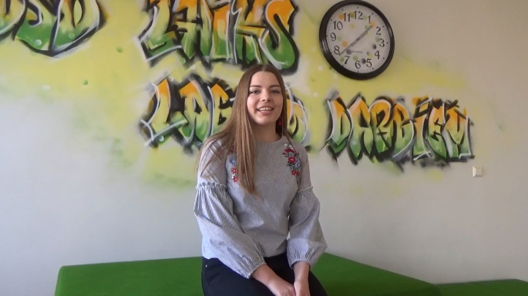
Antra:
People are our hope to bring the name of our country to the world by reaching good results in different areas. We would like to tell you about our hopes for future that people will know the word LATVIA all over the world.

Children are meeting each other to talk about their future hopes that will make their lives better.

Scene I
Lauma: Who would you like to be?
Endija: I would like to be an artist and paint like Līva Pakalne.
Lauma: Who exactly is Līva Pakalne?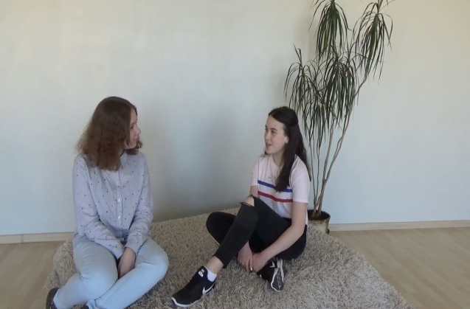
Endija: She is an artist who paints and makes her exhibitions in different countries. You can see her works in Italy, Switzerland and France. She mostly paints portraits.
Who would you like to be?
Lauma: I would like to be an actress like Dita Lūriņa – Egliena. She is a Latvian actress. And since year 2000, she is an actress in Latvian National theatre. She has played in several plays and TV shows.
Endija: Which one is your favourite TV show?
Lauma: My favourite TV show is “Ugunsgrēks”.
Endija: Has she received any awards?
Lauma: Yes, on 18th November 2017 she was awarded with the Order of Three Stars.

Scene II
Loreta: My dream is to be a composer. One of my favourite composers is Raimonds Pauls.
Rūta: Why do you want to be like him?
Loreta: You know that he has written a lot of songs in different languages, music for more than fifty films, three operas and many plays.
Rūta: Has he taken part in any competitions?
Loreta: Yes, during the Soviet time he has participated in many musical competitions. But the most interesting fact is that his song was performed in Japanese, too.
What would you like to be?
Artūrs: I would like to be like Dons who is very well known composer and singer, too.
Loreta: But there are many singers and musicians. Why do you choose him?
Artūrs: He participated in Eurovision Song Contest where he got the second place with his song “My Religion is Freedom”. And what would you like to be?
Rūta: I would like to be like Renārs Kaupers. He is one of the well known Latvian musicians. He is the bands “Brain Storm” lead singer. He has conquered not only the hearts of Latvian music lovers, but also is known all over the world.
Artūrs: What is his biggest success?
Rūta: One of the “Brain Storm`s” Largest success is the third place in Eurovision Song Contest in 2000 with the song “My Star”. In the same year he was nominated as a person of Europe in Latvia.
Scene III
Estere: Who would you like to be?
Ieva: I would like to be an athlete. My favourite one is Laura Ikauniece-Ādmidiņa.
Estere: Why is she your favourite athlete?
Ieva: She is Latvian national recordist. In 2012 she won a silver medal in European Championship, but in 2015 she won a bronze medal in the World Championship.
Estere: But I would like to be like Kristaps Porziņģis.
Ieva: Who is he?
Estere: You don`t know?! He is Latvian most popular basketball player now.
Ieva: Where does he play?
Estere: He plays for NY Knicks of the NBA. And he is 2.21 m tall. I also want to be so popular as Kristaps, everyone knows him.
Final
Antra:
We hope to get so famous as people who we told you about.
Children are our future and maybe each of us will be a new, not discovered hope for Europe.

The Lithuanian play.
Scene 1.
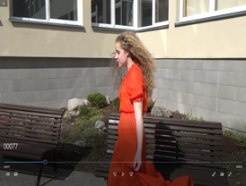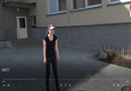
The Sun and The Moon.

The Sun: How are you? Are there any news from the Earth, our daughter??
The Moon: Oh, yes. She has a beautiful little new-born country Lithuania.
The Sun: Where should I look at this little one? Is it somewhere in the desert or in the mountains?
The Moon: No, look for the land at the Baltic Sea. There are a lot of clear lakes and green forests.
The beauty of this country is shining.
The Sun: It’s time for me to start my walk. I’m so curious to see this new-born.

Scene 2.
Somewhere in the forest, a little Lithuania is there. The ancient folk song sounds.

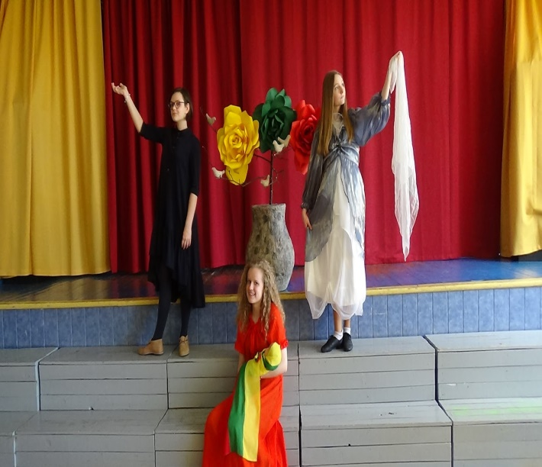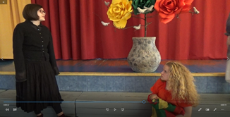

The Sun: Which fortune is waiting for this beauty?

Laumes (witches predicting the fortune).
The Evil Laumė and The Good Laumė appear.
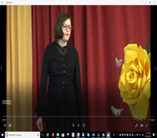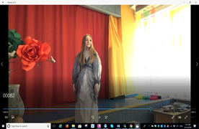

The Evil Laumė: The evil enemies will attack you, both from the east and from the west.
The Good Laumė: But you will always rise from the ashes like Phoenix!
The Evil Laumė: You will have your bread by the sweat of your brow while your friends and neighbours will eat a sweet cake.
The Good Laumė: But you will always have bread to eat, even when your neighbours won’t.
The Evil Laumė: Oh, I’m seeing you will have 100 years of bad luck and poverty!
The Good Laumė: Instead, after those 100 years you will find new friends in Europe and become the happy member of their family. Your trouble and struggle will come to the end. This word is final and unchangeable! This is my solemn oath!!

The ending:
Europe invites everyone to make a semi-circle. All countries raise their hands and say:
1.We are different.
2.We sing different songs.
3.We listen to different music.
4.We speak different languages.
5. We wear different clothes.”
All together: “But we respect the same values.
1.Peace and Love.
2.Family and Friendship.
3.Health and Nature.
4.Beauty and Life.

All together: We are the hope for Europe!”
All participants join them and sing a project song “We wish we could fly”.

